ỦY BAN NHÂN DÂN TP.HCM CỘNG HÒA XÃ HỘI CHỦ NGHĨA VIỆT NAM
TRƯỜNG CAO ĐẲNG LÝ TỰ TRỌNG TPHCM Độc lập – Tự do – Hạnh phúc
********** ******

PHIẾU TRẢ LỜI TRẮC NGHIỆM

Tên: ____________________________________ Đề thi số: 02
Lớp: ___________ Ngày thi: _____________

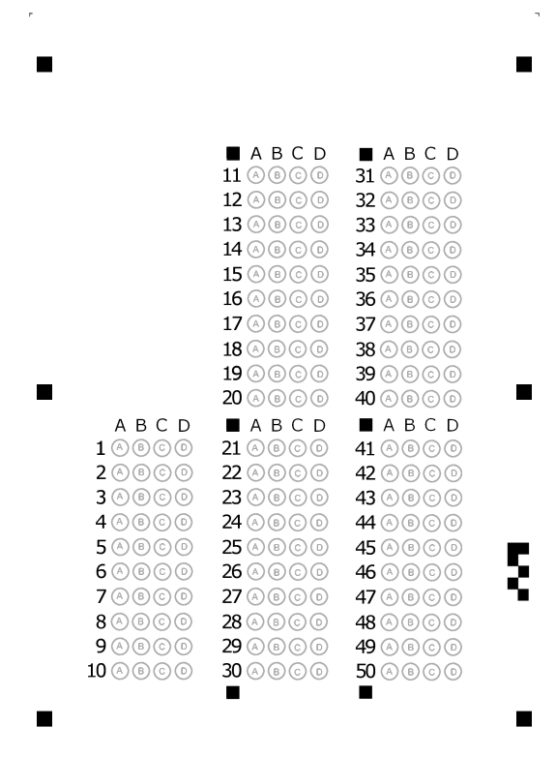

ỦY BAN NHÂN DÂN TP.HCM CỘNG HÒA XÃ HỘI CHỦ NGHĨA VIỆT NAM
TRƯỜNG CAO ĐẲNG LÝ TỰ TRỌNG TPHCM Độc lập – Tự do – Hạnh phúc
********** ******
ĐỀ 2
ĐỀ THI GIỮA HỌC PHẦN LÝ THUYẾT
BẬC ĐÀO TẠO : CAO ĐẲNG
HỌC PHẦN : ANH VĂN
HỌC KỲ : II NĂM HỌC: 2017 - 2018
Lớp: 17C1-NNA1, NNA2 Ngày thi: 16/ 04 / 2018
Thời gian thi : 60 phút
(Sinh viên không được sử dụng tài liệu trong khi làm bài. Sinh viên trả lời vào PHIẾU TRẢ LỜI TRẮC NGHIỆM)
(Đề thi gồm 40 câu. Mỗi câu trả lời đúng được 0.25 điểm)
------------------------------------------------
I. Match the letter A, B, C, or D to indicate the word or phrase that is CLOSET in meaning to the underlined part in each of the following questions
1. She showed her gratitude by saying, “Thank you”
A. purity B. appreciation C. affection D. modesty
2. The essential point is we must do what the contract says.
A. initial B. original C. intentional D. major
3. A procession of marchers and bands moved down Main Street.
A. encounter B. parade C. secrecy D. union
4. He is affluent man.
A. understanding B. elite C. mistaken D. prosperous
5. She spends her hard-earned money sensibly.
A. inadvertently B. wisely C. intentionally D. mistakenly
6. No one knows what happened to the airplane; its disappearance is an enigma.
A. elimination B. exploitation C. removal D. mystery
7. The miners drew out oil from the ground.
A. abstracted B. extracted C. retracted D. contracted
8. They embraced and promised to keep in touch.
A. hugged B. embarked C. embedded D. enclosed
9. The project was running late owing to unforeseen circumstances.
A. unexplained B. unexpired C. unexpected D. unadorned
10. Some of the country’s customs are baffling to outsiders.
A. confusing B. exciting C. fitting D. delighting
II. Choose the best answer for the following sentences
11. The army base is ________ to everyone except military personnel.
A. off-kilter B. off-ramp C. off-beat D. off-limits
12. Some medicines are only available on ________.
A. description B. instruction C. inscription D. prescription
13. There will be a twenty-minute ________ halfway through the performance.
A. stop B. pause C. interval D. gap
14. Have you got a (n) ________ suggestion?
A. changing B. replaced C. various D. alternative
15. Normally he is rather ________ but sometimes he talks freely about himself.
A. sociable B. reserved C. ignorant D. peaceful
16. You should be very ________ to your teachers for their help.
A. thankful B. grateful C. considerate D. gracious
17. I think that the prices here are ________.
A. convenient B. reasonable C. comfortable D. available
18. These snakes will not cause you any serious harm even if they bite you. They are ________.
A. cruel B. poisonous C. harmful D. harmless
19. Dangerous chemicals can be ________ from burning platics or hairspray containers.
A. invented B. escaped C. released D. freed
20. The escaped man has so far succeed in ________ the police.
A. believing B. pretending C. running D. outwitting
III. Read the text and decide that each following statement is True or False
ANGKOR WAT
Visit Angkor Wat
Siem Reap is a small town near the world famous temple of Angkor Wat. The town is charming and worth exploring, with some fine examples of Khmer and French colonial architecture set among the more modern developments. Nowadays, visitors are flocking in, using it as a base for visits to the nearby temples.

A Carved City
From the 9th to the 14th centuries, when Europe was still struggling out of the Dark Ages, the Cambodian Empire of Angkor covered most of present-day Cambodia, Laos, Vietnam, and Thailand. The heart of this empire during the 12th century was the ancient capital of Angkor Thom, near present day Siem Reap, the site of the world’s largest temple complexes, which were rediscovered in 1861.This spectacular city was built over 30 years under the reign of King Suryavarman II (1113-1150). The area covers about 400 square kilometres and is full of the finest examples of Khmer art and architecture. Tourists are always amazed at the scale of the place.

In Angkor Wat you will find more than 100 stone monuments and temple buildings, each of which contains countless statues, sculptures and reliefs that have weathered extremely little over the last 800 years. To see the whole thing can take several days. The most important temples to visit in the area are Angkor Wat, especially at sunrise or sunset; Angkor Thom, the remains of the capital; Ta Prohm, a palace overgrown by jungle; and Bayon.

Getting a visa
Visas are required to enter Cambodia. You can obtain one on arrival at Siem Reap International Airport for $20, and 1 passport photo is required per person. You will also need another passport photo for the Angkor Temple Entrance Pass. Please ensure you take comfortable walking shoes, light clothing and plenty of water to drink as it is very hot there. The most commonly accepted currency in Cambodia is the US dollar.

21. In the 9th to the 14th centuries, Europe was more advanced than Cambodia.
A. True B. False
22. It took many decades to build the capital.
A. True B. False
23. It'll take a couple of days to see everything.
A. True B. False
24. You must get a visa before flying to Siem Reap.
A. True B. False
25. The US dollar is widely accepted in Cambodia.
A. True B. False

IV. Below are descriptions of 8 films showing at the cinema.
A Private Party
A wonderfully funny comedy, which takes place in the 1940s. A reporter and his very worried wife try to save a friendly pig from the local butcher. The actors really make the most of this clever script.
And Tomorrow We Find You
A fast-moving adult story about a San Francisco policeman in danger. Based on real-life happening, it keeps you guessing right until the last minute. Although there are no big stars, there are some fine performances
The Ends of the Earth
A story based on a real-life journey to the South Pole. This film contains some quite wonderful wildlife photography - make sure you see it while you have the chance, or you'll be sorry.
Islands of Fire
You get spectacular scenery and lots of thrills in this action-packed story, in which a young sea-captain rescues terrified villagers from a volcanic island in the South Sea.
A Time of Silence
Don't forget your handkerchief for this story of a young college boy and girl who manage to survive all the pressures of modern life. And what an unforgettable wedding scene!
Out of School
Here we live through a day in the life of an American teenager who has problems not only with his parents and their boring friends but also with his first girl-friend who just doesn't seem to understand him.
The Delivery
Jim Treace stars in this well-known comedy about two workmen who have to deliver a long piece of wood to a house. But unfortunately the performances are poor, and the film is too long for such a simple joke.
Who Shot Malone?
It's a surprise to see so many famous names wasting their time in this dull detective story. In the end you find yourself asking, "Who cares?"
Choose one film for each person that best matches their interests
26. Joanne is studying art at university. She usually goes to the cinema on Friday evening. She enjoys films that are based on real life and from which she can learn something.
A. Islands of Fire C. And Tomorrow We Find You
B. The Ends of the Earth D. Who Shot Malone?
27. Sheila has decided to take her mother to the cinema for her birthday. They both like love stories that have happy endings.
A. A Private Party C. Who Shot Malone?
B. And Tomorrow We Find You D. A Time of Silence
28. Brian is a hard-working medical student. He doesn't have very much free time, but he likes going to the cinema to relax, and enjoys a good laugh.
A. A Private Party C. Who Shot Malone?
B. And Tomorrow We Find You D. Islands of Fire
29. Adam wants to take his 10-year-old son Mark to the cinema at the weekend. They want to see a film with plenty of excitement.
A. Who Shot Malone? C. Out of School
B. And Tomorrow We Find You D. Islands of Fire

30. Harry and Joyce go to the cinema about twice a month. They particularly like detective stories and do not pay much attention to which actors are in the film.
A. And Tomorrow We Find You C. Out of School
B. Who Shot Malone? D. The Delivery
V. Read the text and questions below.
For each question, mark the correct letter A, B, C or D.
An air pollutant is defined as a compound added directly or indirectly by humans to the atmosphere in such quantities as to affect humans, animals, vegetation, or materials adversely. Air pollution requires a very flexible definition that permits continuous change. When the first air pollution laws were established in England in the fourteenth century, air pollutants were limited to compounds that could be seen or smelled - a far cry from the extensive list of harmful substances known today. As technology has developed and knowledge of the health aspects of various chemicals has increased, the list of air pollutants has lengthened. In the future, even water vapor might be considered an air pollutant under certain conditions.
Many of the more important air pollutants, such as sulfur oxides, carbon monoxide, and nitrogen oxides, are found in nature. As the Earth developed, the concentration of these pollutants was altered by various chemical reactions; they became components in biogeochemical cycles. These serve as an air purification scheme by allowing the
compounds to move from the air to the water or soil. On a global basis, nature's output of these compounds dwarfs that resulting from human activities.
However, human production usually occurs in a localized area, such as a city. In such a region, human output may be dominant and may temporarily overload the natural purification scheme of the cycles. The result is an increased concentration of noxious chemicals in the air. The concentrations at which the adverse effects appear will be greater than the concentrations that the pollutants would have in the absence of human activities. The actual concentration need not be large for a substance to be a pollutant; in fact, the numerical value tells us little until we know how much of an increase this represents over the concentration that would occur naturally in the area. For example, sulfur dioxide has detectable health effects at 0.08 parts per million (ppm), which is about 400 times its natural level. Carbon monoxide, however, has a natural level of 0.1 ppm and is not usually a pollutant until its level reaches about 15 ppm.

31. What does the passage mainly discuss?
A. The economic impact of air pollution.
B. What constitutes an air pollutant.
C. How much harm air pollutants can cause.
D. The effects of compounds added to the atmosphere.
32. The word “adversely” in the first paragraph is closest in meaning to _____.
A. negatively B. quickly C. admittedly D. considerably
33. It can be inferred from the first paragraph that _____.
A. water vapor is an air pollutant in localized areas
B. most air pollutants today can be seen or smelled
C. the definition of air pollution will continue to change
D. a substance becomes an air pollutant only in cities
34. The word “These” in the second paragraph is closest in meaning to _____.
A. the various chemical reactions C. the compounds moved to the water or soil
B. the pollutants from the developing Earth D. the components in biogeochemical cycles
35. For which of the following reasons can natural pollutants play an important role in controlling air pollution?
A. They function as part of a purification process.
B. They occur in greater quantities than other pollutants.
C. They are less harmful to living beings than other pollutants.
D. They have existed since the Earth developed.
36. According to the passage, human-generated air pollution in localized regions _____.
A. can be dwarfed by nature's output of pollutants
B. can overwhelm the natural system that removes pollutants
C. will damage areas outside of the localized regions
D. will react harmfully with natural pollutants
37. The word “localized” in the third paragraph is closest in meaning to _____.
A. specified B. circled C. surrounded D. encircled
38. According to the passage, the numerical value of the concentration level of a substance is only useful if _____.
A. the other substances in the area are known C. the natural level is also known
B. it is in a localized area D. it can be calculated quickly
39. The word “detectable” in the third paragraph is closest in meaning to _____.
A. beneficial B. special C. measurable D. separable
40. Which of the following is best supported by the passage?
A. To effectively control pollution, local government should regularly review their air pollution laws.
B. One of the most important steps in preserving natural lands is to better enforce air pollution laws.
C. Scientists should be consulted in order to establish uniform limits for all air pollutants.
D. Human activities have been effective in reducing air pollution.

The End of the Test

Trưởng khoa Giáo viên soạn đề

Trần Kim Thu Liễu Đinh Trần Phương Thảo

